Second Sunday of Christmas
January 3, 2021
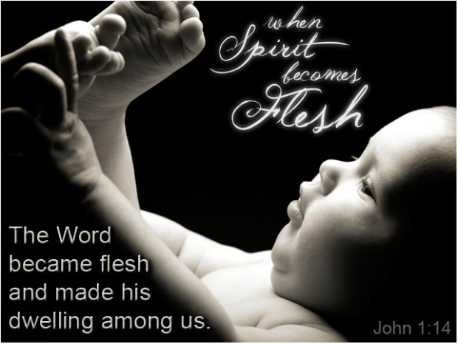
graphic: http://www.heartlight.org
St. Mark’s Evangelical Lutheran Church
933 Brookline Blvd.
Pittsburgh, PA 15226

Rev. Randall J. Marburger
Interim Pastor

(717) 364-9971 (Cell)
rajoma69@gmail.com

Church Office : (412) 531-9575

Internet : stmarkbrookline.wixsite.com/smlc
Email : stmarklutheranchurch@verizon.net Facebook : facebook.com/SMLCbrookline

Please join with us on Zoom at 9:30 AM Sundays
Join by computer using Zoom: Meeting ID = 856 2680 1615 Password = church
Join by phone: Dial in # = (301) 715-8592
Meeting ID = 856 2680 1615 Password = 280633
Introduction to the day
Within the gospel reading’s profound words lies the simple message that God is revealed in a human person. Though we may try to understand how the Word existed with God from the beginning of time, the wonder we celebrate at Christmas is that the Word continues to dwell among us. Christ comes among us in the gathered assembly, the scriptures, the waters of new birth, and the bread and the wine. Through these ordinary gifts we receive the fullness of God’s grace and truth.

OUR PURPOSE
We are called and empowered by God to lead our family, friends, and community into a deeper relationship with Jesus Christ.
OUR MISSION
We will listen to, equip, and accompany each person on their journey to know God’s love and the plan of salvation.

- - - - - - - - - - - - - -

St. Mark’s Lutheran Church
Second Sunday of Christmas – January 3, 2021

Order of Worship
PRELUDE
P. This is the day that the Lord has made.
C. Let us rejoice and be glad in it. (Psalm 118:24)

ANNOUNCEMENTS and PRAYER REQUESTS

SHARING God Sightings

CONFESSION
In the name of the Father, and of the ☩ Son, and of the Holy Spirit.
Amen.

Almighty God, to whom all hearts are open, all desires known, and from whom no secrets are hid: Cleanse the thoughts of our hearts by the inspiration of your Holy Spirit, that we may perfectly love you and worthily magnify your holy name, through Jesus Christ our Lord.
Amen.

If we say we have no sin, we deceive ourselves, and the truth is not in us. But if we confess our sins, God who is faithful and just will forgive our sins and cleanse us from all unrighteousness.

Most merciful God…..

We confess that we are in bondage to sin and cannot free ourselves. We have sinned against you in thought, word, and deed, by what we have done and by what we have left undone. We have not loved you with our whole heart; we have not loved our neighbors as ourselves. For the sake of your Son, Jesus Christ, have mercy on us. Forgive us, renew us, and lead us, so that we may delight in your will and walk in your ways, to the glory of your holy name. Amen.

Almighty God, in his mercy, has given his Son to die for us and, for his sake, forgives us all our sins. As a called and ordained minister of the Church of Christ, and by his authority, I therefore declare to you the entire forgiveness of all your sins, in the name of the Father, and of the ☩ Son, and of the Holy Spirit.
Amen.

ENTRANCE HYMN
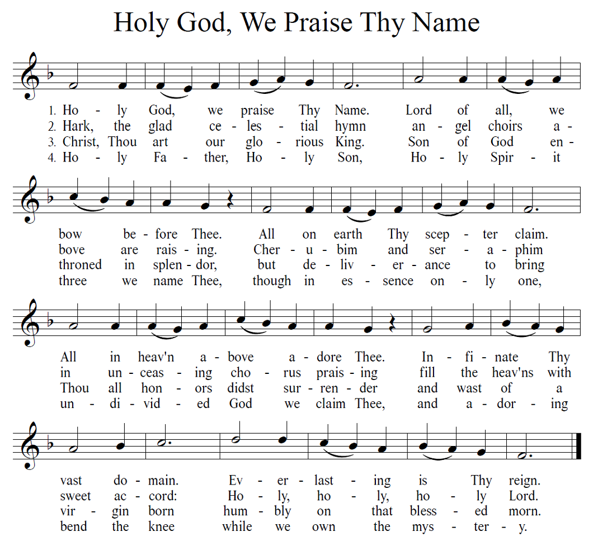
GREETING
The grace of our Lord Jesus Christ, the love of God and the communion of the Holy Spirit be with you all.
And also with you.
The Word was made flesh, and we beheld his glory.
Oh, come, let us worship him.
Today Christ is born; today salvation has appeared.
Today the faithful say in exultation, “Glory to God in the highest.”

CHRISTMAS DIALOG
Oh, sing to the Lord a new song! Sing to the Lord, all the earth.
Declare his glory among the nations, his wonders among all the peoples.
Give to the Lord the glory due his name; bring an offering, and come into his courts.
Worship the Lord in the beauty of holiness; tremble before him, all the earth.
Let the heavens rejoice, let the earth be glad, let the sea roar, let the field be joyful!
All the trees of the forest, shout for joy before the Lord, who comes to judge the earth with righteousness and the peoples with truth.

HYMN OF PRAISE (LBW Setting 2 pg. 79 to be sung)
Glory to God in the highest and peace to his people on earth.

Lord God, heavenly king, almighty God and Father;
We worship you, we give you thanks, we praise you for your glory.
Lord Jesus Christ, only Son of the Father,
Lord God, Lamb of God: You take away the sin of the world; have mercy on us.
You are seated at the right hand of the Father; receive our prayer.
For you alone are the Holy One, you alone are the Lord,
You alone are the Most High, Jesus Christ, with the Holy Spirit,
In the glory of God the Father, Amen.

PRAYER OF THE DAY
Let us pray.
Almighty God, you have filled all the earth with the light of your incarnate Word. By your grace empower us to reflect your light in all that we do, through Jesus Christ, our Savior and Lord, who lives and reigns with you and the Holy Spirit, one God, now and forever.
Amen.

FIRST READING: Jeremiah 31:7-14
A reading from Jeremiah.
⁷Thus says the Lord:
Sing aloud with gladness for Jacob,
and raise shouts for the chief of the nations;
proclaim, give praise, and say,
“Save, O Lord, your people,
the remnant of Israel.”
⁸See, I am going to bring them from the land of the north,
and gather them from the farthest parts of the earth,
among them the blind and the lame,
those with child and those in labor, together;
a great company, they shall return here.
⁹With weeping they shall come,
and with consolations I will lead them back,
I will let them walk by brooks of water,
in a straight path in which they shall not stumble;
for I have become a father to Israel,
and Ephraim is my firstborn.
¹⁰Hear the word of the Lord, O nations,
and declare it in the coastlands far away;
say, “He who scattered Israel will gather him,
and will keep him as a shepherd a flock.”
¹¹For the Lord has ransomed Jacob,
and has redeemed him from hands too strong for him.
¹²They shall come and sing aloud on the height of Zion,
and they shall be radiant over the goodness of the Lord,
over the grain, the wine, and the oil,
and over the young of the flock and the herd;
their life shall become like a watered garden,
and they shall never languish again.
¹³Then shall the young women rejoice in the dance,
and the young men and the old shall be merry.
I will turn their mourning into joy,
I will comfort them, and give them gladness for sorrow.
¹⁴I will give the priests their fill of fatness,
and my people shall be satisfied with my bounty,
says the Lord.

The word of the Lord.
Thanks be to God.

PSALM: Psalm 147:12-20 (Read in unison.)
¹²Worship the Lord, O Jerusalem;
praise your God, O Zion,
¹³who has strengthened the bars of your gates
and has blessed your children within you.
¹⁴God has established peace on your borders
and satisfies you with the finest wheat.
¹⁵God sends out a command to the earth,
a word that runs very swiftly.
¹⁶God gives snow like wool,
scattering frost like ashes.
¹⁷God scatters hail like bread crumbs.
Who can stand against God’s cold?
¹⁸The Lord sends forth the word and melts them;
the wind blows, and the waters flow.
¹⁹God declares the word to Jacob,
statutes and judgments to Israel.
²⁰The Lord has not done so to any other nation;
they do not know God’s judgments. Hallelujah!

SECOND READING: Ephesians 1:3-14
A reading from Ephesians.
³Blessed be the God and Father of our Lord Jesus Christ, who has blessed us in Christ with every spiritual blessing in the heavenly places, ⁴just as he chose us in Christ before the foundation of the world to be holy and blameless before him in love. ⁵He destined us for adoption as his children through Jesus Christ, according to the good pleasure of his will, ⁶to the praise of his glorious grace that he freely bestowed on us in the Beloved. ⁷In him we have redemption through his blood, the forgiveness of our trespasses, according to the riches of his grace ⁸that he lavished on us. With all wisdom and insight ⁹he has made known to us the mystery of his will, according to his good pleasure that he set forth in Christ, ¹⁰as a plan for the fullness of time, to gather up all things in him, things in heaven and things on earth. ¹¹In Christ we have also obtained an inheritance, having been destined according to the purpose of him who accomplishes all things according to his counsel and will, ¹²so that we, who were the first to set our hope on Christ, might live for the praise of his glory. ¹³In him you also, when you had heard the word of truth, the gospel of your salvation, and had believed in him, were marked with the seal of the promised Holy Spirit; ¹⁴this is the pledge of our inheritance toward redemption as God’s own people, to the praise of his glory.

The word of the Lord.
Thanks be to God.

Response (Sing verse 2 of “Angels, from the Realms of Glory”)
Shepherds in the fields abiding,
Watching o’er your flocks by night,
God with us is now residing,
Yonder shines the infant light.
Come and worship, come and worship,
Worship Christ, the newborn king.

GOSPEL: John 1:[1-9] 10-18
The Holy Gospel according to John.
Glory to you, O Lord.
[¹In the beginning was the Word, and the Word was with God, and the Word was God. ²He was in the beginning with God. ³All things came into being through him, and without him not one thing came into being. What has come into being ⁴in him was life, and the life was the light of all people. ⁵The light shines in the darkness, and the darkness did not overcome it.
⁶There was a man sent from God, whose name was John. ⁷He came as a witness to testify to the light, so that all might believe through him. ⁸He himself was not the light, but he came to testify to the light. ⁹The true light, which enlightens everyone, was coming into the world.] ¹⁰He was in the world, and the world came into being through him; yet the world did not know him. ¹¹He came to what was his own, and his own people did not accept him. ¹²But to all who received him, who believed in his name, he gave power to become children of God, ¹³who were born, not of blood or of the will of the flesh or of the will of man, but of God.
¹⁴And the Word became flesh and lived among us, and we have seen his glory, the glory as of a father’s only son, full of grace and truth. ¹⁵(John testified to him and cried out, “This was he of whom I said, ‘He who comes after me ranks ahead of me because he was before me.’ ”) ¹⁶From his fullness we have all received, grace upon grace. ¹⁷The law indeed was given through Moses; grace and truth came through Jesus Christ. ¹⁸No one has ever seen God. It is God the only Son, who is close to the Father’s heart, who has made him known.

The gospel of the Lord.
Praise to you, O Christ.

SERMON

HYMN of the DAY
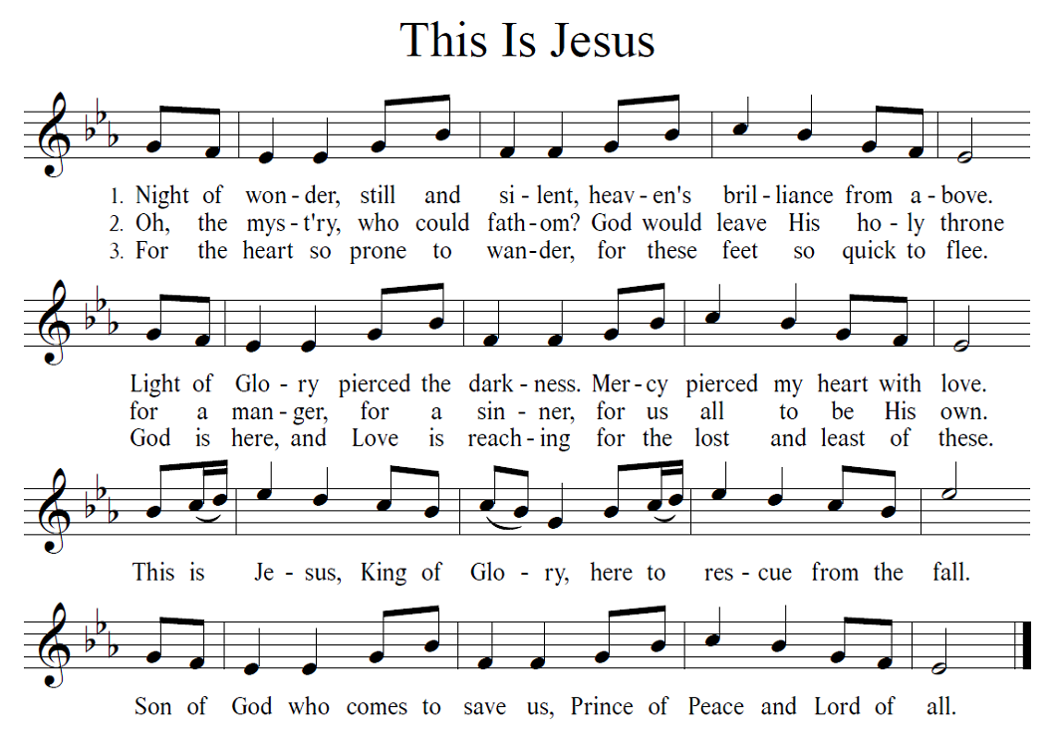
NICENE CREED
We believe in one God,
the Father, the Almighty,
maker of heaven and earth,
of all that is, seen and unseen.
We believe in one Lord, Jesus Christ,
the only Son of God,
eternally begotten of the Father,
God from God, Light from Light,
true God from true God,
begotten, not made,
of one Being with the Father;
through him all things were made.
For us and for our salvation
he came down from heaven,
was incarnate of the Holy Spirit and the virgin Mary
and became truly human.
For our sake he was crucified under Pontius Pilate;
he suffered death and was buried.
On the third day he rose again
in accordance with the scriptures;
he ascended into heaven
and is seated at the right hand of the Father.
He will come again in glory to judge the living and the dead,
and his kingdom will have no end.
We believe in the Holy Spirit, the Lord, the giver of life,
who proceeds from the Father and the Son,*
who with the Father and the Son is worshiped and glorified,
who has spoken through the prophets.
We believe in one holy catholic and apostolic church.
We acknowledge one baptism for the forgiveness of sins.
We look for the resurrection of the dead,
and the life of the world to come. Amen.

PRAYERS of INTERCESSION
Joining our voices with the song of the angels, let us pray for the church, the world, and all who are in need.
Redeeming God, you gather together your people from the farthest parts of the earth. Protect your church from stumbling. Let it not be overcome by sorrow, division, or despair. Make us radiant with goodness, that we might live always to the praise of your glory. Hear us, O God.
Your mercy is great.
You bring together heaven and earth. All creation testifies to your splendor. Hold the ecosystems of this earth in delicate balance, from coastlands to farmlands, forests to wetlands, deserts to rainforests. Show us new ways to live in harmony with the world around us. Hear us, O God.
Your mercy is great.
You overflow with grace upon grace. Expand the imaginations of those who serve in positions of authority. Open their hearts to the needs of their nations and communities. Protect all those in harm’s way and those risking danger for the sake of others. Hear us, O God.
Your mercy is great.
You bring consolation to those who weep. Embrace those who feel far-off, excluded, or defeated. Accompany those living with chronic and invisible illness. Sustain the weak and weary. Refresh those who labor under the weight of pain or sickness (especially). Hear us, O God.
Your mercy is great.
You come to us in the beauty of darkness and of light. Bring justice and reconciliation to communities divided by oppressions and misuse of power. Guide us to speak holy words of advocacy and truth. Help us to honor your image in one another. Hear us, O God.
Your mercy is great.
You turn our mourning into joy. We give thanks for those who have died in faith (especially). With all the saints, give us our inheritance in Christ. In the fullness of time, gather us all together in your mercy. Hear us, O God.
Your mercy is great.
God of mercy, come quickly to us with grace upon grace as we lift these and all our prayers to you, in the name of Jesus.
Amen.

LORD’S PRAYER
Our Father, who art in heaven,
hallowed be thy name,
thy kingdom come,
thy will be done,
on earth as it is in heaven.
Give us this day our daily bread;
and forgive us our trespasses,
as we forgive those
who trespass against us;
and lead us not into temptation,
but deliver us from evil.
For thine is the kingdom,
and the power, and the glory,
forever and ever. Amen.

BENEDICTION
Jesus is the Word made flesh in our midst. May his incarnation fill your hearts with joy and peace.
Amen.
Jesus is the promised Savior, born of Mary. May his birth among us renew your hope.
Amen.
Jesus is the King of kings and the Lord of lords. May the gift of his presence bring forth rejoicing.
Amen.

Almighty God, Father, ☩ Son, and Holy Spirit, bless you now and forever.
Amen.

SENDING HYMN
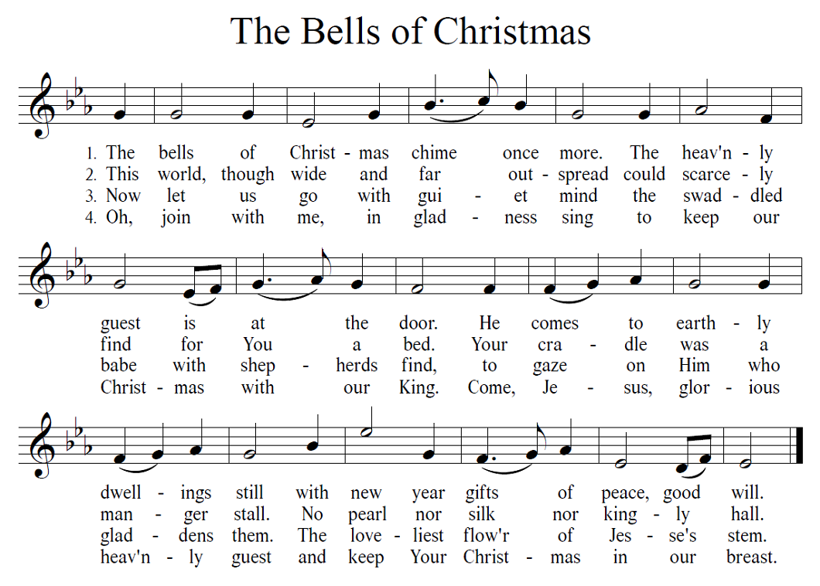
DISMISSAL
Go in peace. Share the Good News.
Thanks be to God.

POSTLUDE
- - - - - - - - - - - - - - - - - - - - - - - - - - - - - - - - - - - - - - - - -
Announcements
Adult Sunday School Join us at 7:00 PM Sunday 1/3/2021
Lectionary study on Jeremiah 31:7-14, Ephesians 1:3-14, John 1:10-18
Teacher – Sue Ingold
Join using Zoom on your pc: Join by phone: Dial (301) 715-8592
Meeting ID: 861 6423 0510 Meeting ID: 861 6423 0510
Password: church Password: 561013

Happy Birthday to

Jeanette Jones | 1/12
Dalene Zinn | 1/12
Toni Weber | 1/16
Janet Zottoli | 1/20
Robby Weihaus | 1/23
Egon Klatt | 1/27

Please let the secretary know if anyone’s
birthday is missed or incorrect.

- - - - - - - - - - - - - - - - - - - - - - - - - - - - - - - - - - - - - - - - -

GOSPEL MESSAGE
January 3, 2021
SECOND SUNDAY OF CHRISTMAS
Truth beyond the Facts
There are many questions today about facts. Who do we trust to give us the facts? What sources and individuals are reliable? Social media can be a great tool for sharing, but it has also become a means of spreading misinformation, false beliefs, and bad advice. Many people today are suspicious of what some claim to be the facts.
Even if we have the right facts, we might not have something more important: the truth. Facts can be a partial representation of the truth. Facts might tell us that it is sunny and warm this morning, but the weather forecast might say thunderstorms are coming in the afternoon. The latter statement is truth. Truth is the larger reality that smaller facts don’t capture, and sometimes contradict.
John tells us that Jesus is God’s Word, full of grace and truth. In Jesus we get the full truth of God, not merely the facts. What are the facts we might see? We are all sinful and have strayed from God’s just and loving ways. The world is a mess. Left to our own ways, we are surely lost. These are the facts, as if we woke up to a dangerous thunderstorm but don’t know what the weather forecast is after that. Jesus is the fuller truth that in spite of the stormy mess of the world and our individual lives, God’s grace is a gift to us in Christ. There is a blue sky and a safe calm that is ours through divine love.
Some of us live with messages that tell us we are not the right kind of person to receive God’s grace because of our past mistakes, or ethnicity, or gender identity, or level of education, or poverty. The truth of Jesus Christ tells us we are children of God. “From his fullness we have all received, grace upon grace” (John 1:16). This is the truth that gives us life.

