MAY 15, 2022
5th Sunday of Easter

St. Mark’s Lutheran Church
933 Brookline Blvd.
Pittsburgh, PA 15226
412-561-9575
Rev. Gregg Knepp
Phone: 443-397-5970

Internet : stmarkbrookline.wixsite.com/smlc
Email : stmarklutheranchurch@verizon.net
Facebook : facebook.com/SMLCbrookline

Please join us on Zoom at 9:30 am Sunday

Join by computer using Zoom: Meeting ID = 856 2680 1615 Password = church
OR
Join by phone: Dial-in # = (301) 715-8592
Meeting ID = 856 2680 1615 Password = 280633

Our Purpose
We are called and empowered by God to lead our family friends, and community
into a deeper relationship with Jesus Christ.
Our Mission
We will listen to, equip, and accompany each person on their journey to know
God’s love and the plan of salvation.

+ + + + + +
Introduction to the day
+ + + + + +

Easter initiates a new day. It anticipates a new heaven and a new earth. The risen Christ is making all things new. In the mystery of holy baptism God has made new people of us. Today Jesus invites us to see everyone in a new light—through the lens of love.
.

St. Mark’s Evangelical Lutheran Church
5th Sunday of Easter

Order of Worship
* Please stand as you are able.
PRELUDE

Gathering

Pastor: Christ is risen!
Cong: He is risen indeed!

He is risen!
He is risen indeed!

He is risen!
Alleluia! He is risen indeed!

The Holy Spirit calls us together as the people of God.

ANNOUNCEMENTS

SHARING God Sightings

* (Please stand.)

Blessed be the holy Trinity, ☩ one God, who forgives all our sin, whose mercy endures forever.
Amen.

(Silence is kept for reflection.)

* Confession and forgiveness

God of all mercy and consolation, come to the help of Your people, turning us from our sin to live for You alone. Give us the power of Your Holy Spirit that we may confess our sin, receive Your forgiveness, and grow into the fullness of Jesus Christ, our Savior and Lord.
Amen.

Let us confess our sin in the presence of God and of one another.

Gracious God ...
... have mercy on us. We confess that we have turned from You and given ourselves into the power of sin. We are truly sorry and humbly repent. In Your compassion forgive us our sins, known and unknown, things we have done and things we have failed to do. Turn us again to You, and uphold us by Your Spirit, so that we may live and serve You in newness of life through Jesus Christ, our Savior and Lord. Amen.

God, who is rich in mercy, loved us even when we were dead in sin, and made us alive together with Christ. By grace you have been saved. In the name of ☩ Jesus Christ, your sins are forgiven. Almighty God strengthen you with power through the Holy Spirit, that Christ may live in your hearts through faith.
Amen.

* HYMN
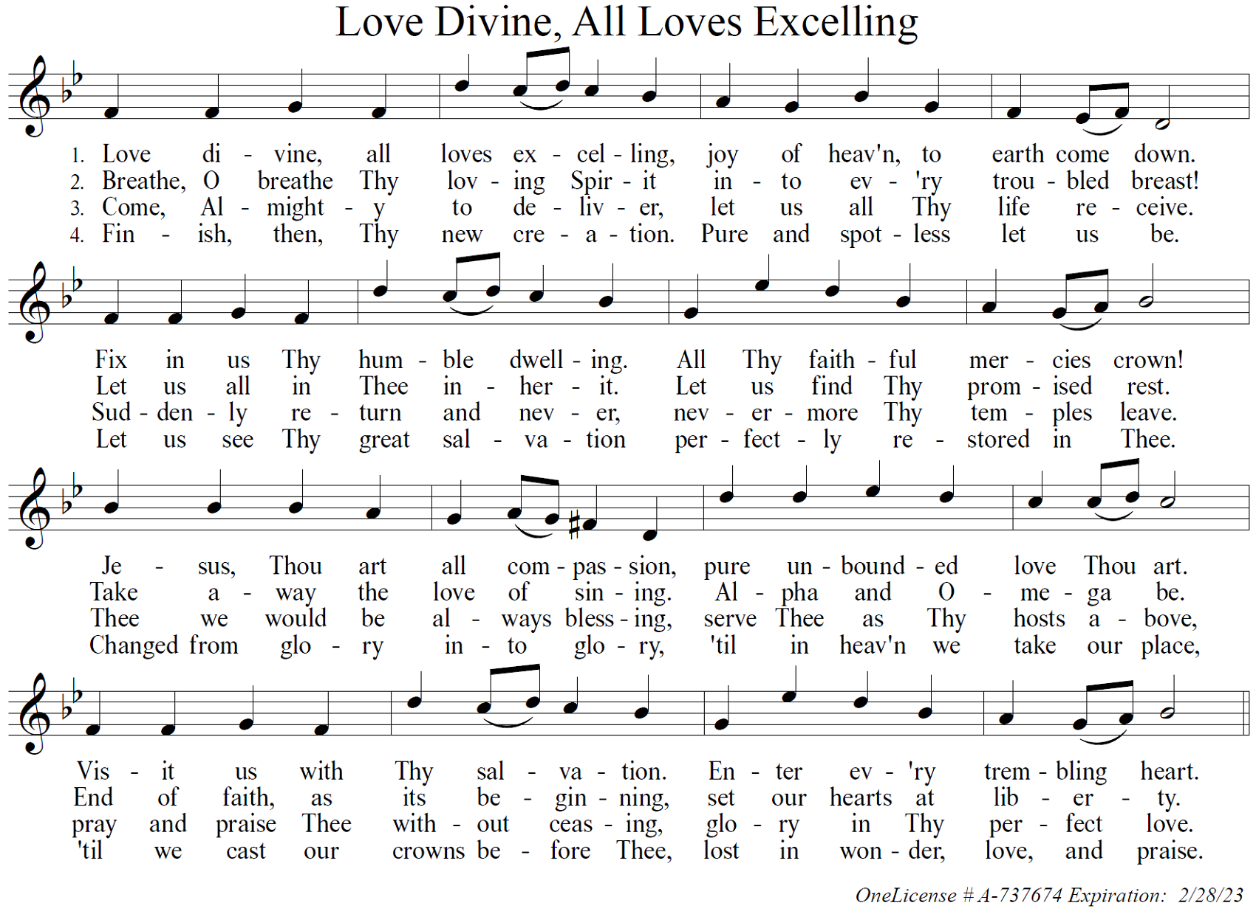

* GREETING

The grace of our Lord Jesus Christ, the love of God, and the communion of the Holy Spirit be with you all.
And also with you.

* SONG OF PRAISE

Praise be forever to our risen Lord!
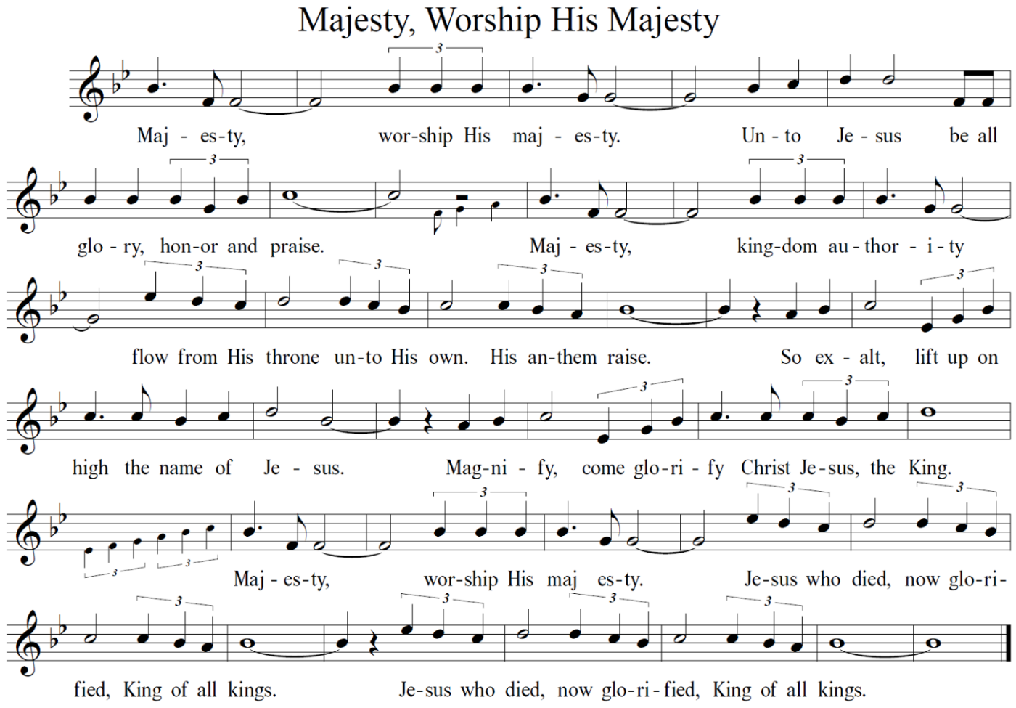

* Prayer of the Day

Let us pray.
Eternal and all-merciful God, with all the angels and all the saints we laud your majesty and might. By the resurrection of your Son, show yourself to us and inspire us to follow Jesus Christ, our Savior and Lord, who lives and reigns with you and the Holy Spirit, one God, now and forever.
Amen.

(Please be seated.)

THE WORD

The first reading for today is from the 11th chapter of Acts. Reader: Karen Arnold

FIRST READING: Acts 11:1-18
¹Now the apostles and the believers who were in Judea heard that the Gentiles had also accepted the word of God. ²So when Peter went up to Jerusalem, the circumcised believers criticized him, ³saying, “Why did you go to uncircumcised men and eat with them?” ⁴Then Peter began to explain it to them, step by step, saying, ⁵“I was in the city of Joppa praying, and in a trance I saw a vision. There was something like a large sheet coming down from heaven, being lowered by its four corners; and it came close to me. ⁶As I looked at it closely I saw four-footed animals, beasts of prey, reptiles, and birds of the air. ⁷I also heard a voice saying to me, ‘Get up, Peter; kill and eat.’ ⁸But I replied, ‘By no means, Lord; for nothing profane or unclean has ever entered my mouth.’ ⁹But a second time the voice answered from heaven, ‘What God has made clean, you must not call profane.’ ¹⁰This happened three times; then everything was pulled up again to heaven. ¹¹At that very moment three men, sent to me from Caesarea, arrived at the house where we were. ¹²The Spirit told me to go with them and not to make a distinction between them and us. These six brothers also accompanied me, and we entered the man’s house. ¹³He told us how he had seen the angel standing in his house and saying, ‘Send to Joppa and bring Simon, who is called Peter; ¹⁴he will give you a message by which you and your entire household will be saved.’ ¹⁵And as I began to speak, the Holy Spirit fell upon them just as it had upon us at the beginning. ¹⁶And I remembered the word of the Lord, how he had said, ‘John baptized with water, but you will be baptized with the Holy Spirit.’ ¹⁷If then God gave them the same gift that he gave us when we believed in the Lord Jesus Christ, who was I that I could hinder God?” ¹⁸When they heard this, they were silenced. And they praised God, saying, “Then God has given even to the Gentiles the repentance that leads to life.”

The word of the Lord.
Thanks be to God.

Psalm 148 (Please read responsively)
¹Hallelujah! Praise the Lord from the heavens;
praise him in the heights.
²Praise him, all you angels of his;
praise him, all his host.
³Praise him, sun and moon;
praise him, all you shining stars.
⁴Praise him, heaven of heavens,
and you waters above the heavens.
⁵Let them praise the name of the Lord;
for he commanded, and they were created.
⁶He made them stand fast forever and ever;
he gave them a law which shall not pass away.
⁷Praise the Lord from the earth,
you sea monsters and all deeps;
⁸fire and hail, snow and fog,
tempestuous wind, doing his will;
⁹mountains and all hills,
fruit trees and all cedars;
¹⁰wild beasts and all cattle,
creeping things and winged birds;
¹¹kings of the earth and all peoples,
princes and all rulers of the world;
¹²young men and maidens,
old and young together.
¹³Let them praise the name of the Lord,
for his name only is exalted, his splendor is over earth and heaven.
¹⁴He has raised up strength for his people and praise for all his loyal servants,
the children of Israel, a people who are near him. Hallelujah!

Revelations 21:1-6

The second reading for the day is from the book of Revelation.

¹I saw a new heaven and a new earth; for the first heaven and the first earth had passed away, and the sea was no more. ²And I saw the holy city, the new Jerusalem, coming down out of heaven from God, prepared as a bride adorned for her husband. ³And I heard a loud voice from the throne saying,
“See, the home of God is among mortals.
He will dwell with them;
they will be his peoples,
and God himself will be with them;
⁴he will wipe every tear from their eyes.
Death will be no more;
mourning and crying and pain will be no more,
for the first things have passed away.”
⁵And the one who was seated on the throne said, “See, I am making all things new.” Also he said, “Write this, for these words are trustworthy and true.” ⁶Then he said to me, “It is done! I am the Alpha and the Omega, the beginning and the end. To the thirsty I will give water as a gift from the spring of the water of life.”

The word of the Lord.
Thanks be to God.

* GOSPEL ACCLAMATION
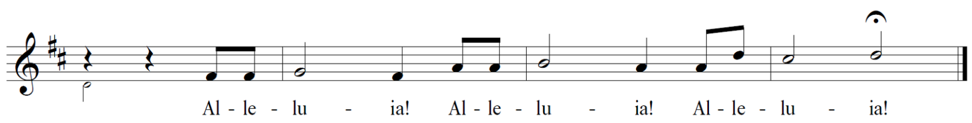

The Holy Gospel according to John’s 13th chapter.
Glory to You, O Lord.

John 13:31-35
³¹When he had gone out, Jesus said, “Now the Son of Man has been glorified, and God has been glorified in him. ³²If God has been glorified in him, God will also glorify him in himself and will glorify him at once. ³³Little children, I am with you only a little longer. You will look for me; and as I said to the Jews so now I say to you, ‘Where I am going, you cannot come.’ ³⁴I give you a new commandment, that you love one another. Just as I have loved you, you also should love one another. ³⁵By this everyone will know that you are my disciples, if you have love for one another.”

The gospel of the Lord.
Praise to you, O Christ.

CHILDREN’S MESSAGE

SERMON “I Give You A.
New Command” Pastor Gregg

SERMON NOTES

* HYMN
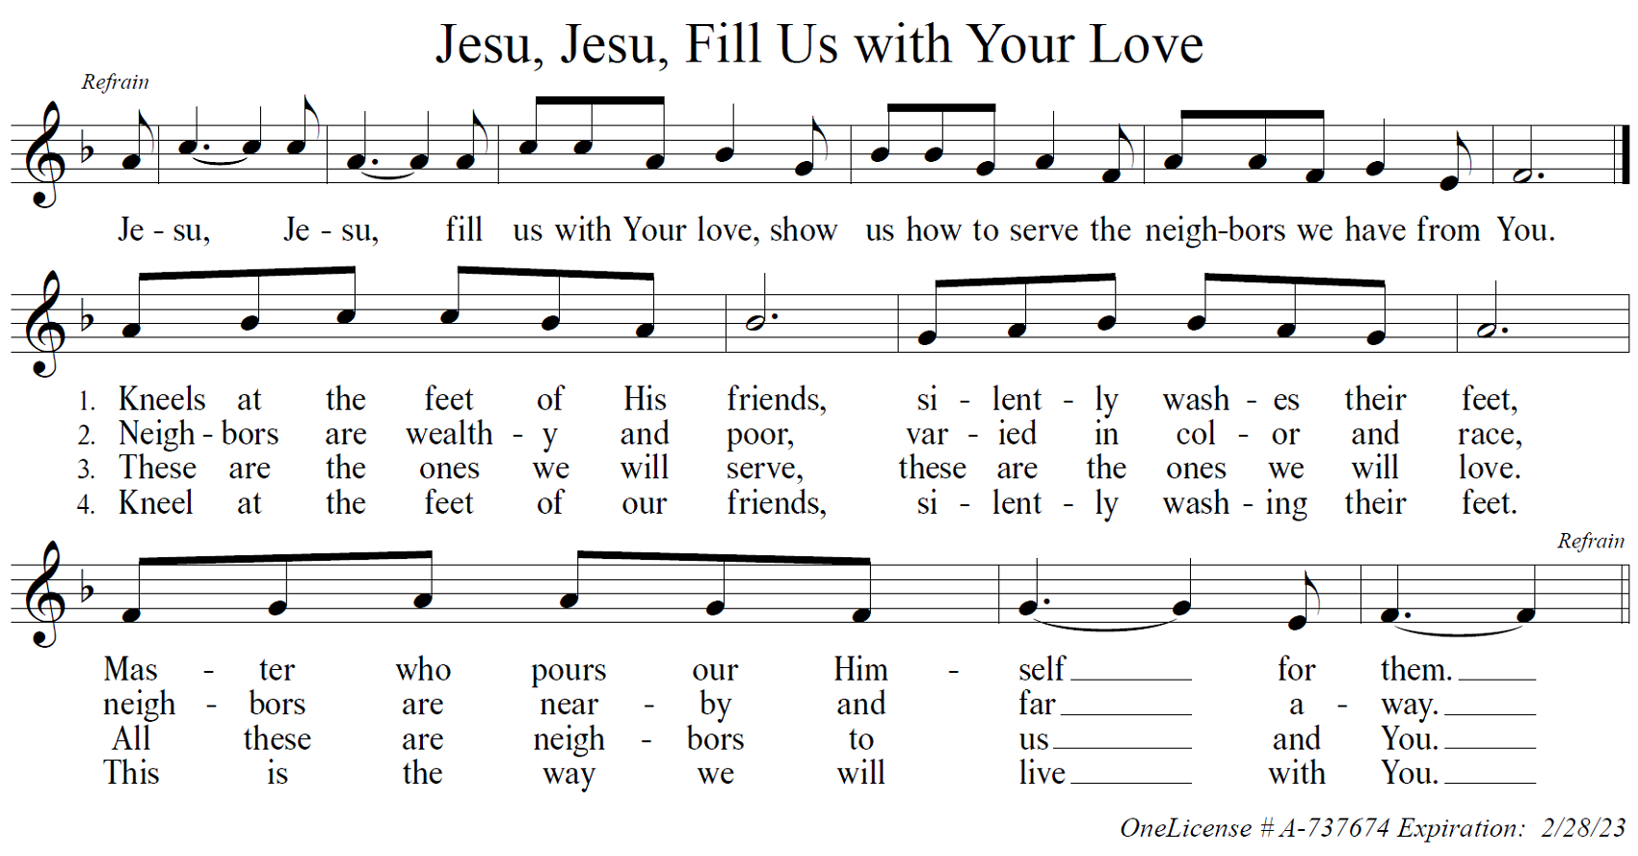
* THE NICENE CREED

We believe in one God, the Father, the Almighty, maker of heaven and earth, of all that is, seen and unseen.

We believe in one Lord, Jesus Christ, the only Son of God, eternally begotten of the Father, God from God, Light from Light, true God from true God, begotten, not made, of one Being with the Father. Through Him all things were made. For us and for our salvation He came down from heaven; by the power of the Holy Spirit He became incarnate from the virgin Mary, and was made man. For our sake He was crucified under Pontius Pilate; He suffered death and was buried. On the third day He rose again in accordance with the Scriptures; He ascended into heaven and is seated at the right hand of the Father. He will come again in glory to judge the living and the dead, and His kingdom will have no end.

We believe in the Holy Spirit, the Lord, the giver of life, who proceeds from the Father and the Son. With the Father and the Son He is worshiped and glorified. He has spoken through the prophets. We believe in one holy catholic and apostolic Church. We acknowledge one Baptism for the forgiveness of sins. We look for the resurrection of the dead, and the life of the world to come. Amen.

* Prayers of Intercession
Set free from captivity to sin and death, we pray to the God of resurrection for the church, people in need, and all of creation.
(A brief silence is kept for reflection.)
Loving God, lead us to follow your Spirit, rather than our own prejudices or desires, as the church cares for one another. Open us to perceive your gifts in those we least expect. God, in your mercy,
hear our prayer.
Inspire us to praise you through the beauty and majesty of the natural world around us. Urge us toward more deliberate care of the world you have made. God, in your mercy,
hear our prayer.
Humble the rulers of nations before your splendor. Direct them to the people who need their attention most, and turn them from the temptation to hoard wealth or power. God, in your mercy,
hear our prayer.
Strengthen and sustain all who support vulnerable people across the world especially the Ukraine and Russia. Break barriers that prevent political enemies from working together for the well-being of all. Make a way for peace and collaboration among the nations. Awaken elected leaders and government officials to work for peace for the needs of those who are oppressed. Empower government agencies and international organizations that provide for refugees and migrants forced to leave their homelands. God, in your mercy,
hear our prayer.
Hasten to dwell among those who are in pain or distress especially. . . . As Christ enters our deepest suffering, remain with those experiencing despair and great need. God, in your mercy,
hear our prayer.
Seek out those who weep while they await healing or consolation especially. . . . Set people in their path who can provide the care they need, and wipe away every tear from their eyes. God, in your mercy,
hear our prayer.
Merciful and gracious God, we thank and praise you for . . . . . God, in your mercy
Hear our prayer.
Enfold us in the great multitude of saints from every nation, from all tribes and peoples and languages. Wash us in your saving grace every day, guiding us to your waters of life. God, in your mercy,
hear our prayer.
Place holy love at the center of all our relationships and communities. By your love heal us, convict us, and renew us. Bring an end to racism in our churches and communities. Let everyone know your goodness by the love we show one another. God, in your mercy,
hear our prayer.
Give us a place in the diverse company of your beloved saints. Teach us the value of each person’s identity, and bless us with a shared identity as your children, kindred of Christ. God, in your mercy,
hear our prayer.
In your mercy, O God, respond to these prayers, and renew us by your life-giving Spirit; through Jesus Christ, our Savior.
Amen.

* OFFERING SONG
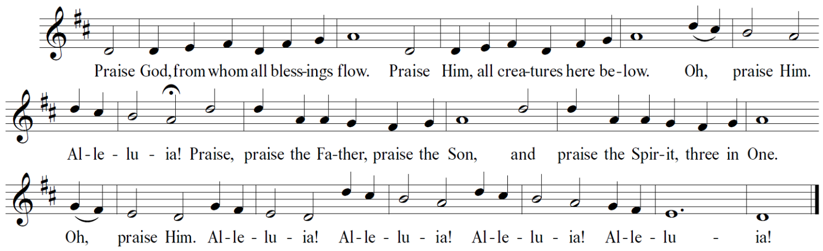

The peace of the Lord be with you always.
And also with you.

* OFFERING PRAYER
Let us pray.
Blessed are You, O God, ruler of heaven and earth. Day by day you shower us with blessings. As You have raised us to new life in Christ, give us glad and generous hearts, ready to praise You and to respond to those in need, through Jesus Christ, our Savior and Lord. Amen.
* GREAT THANKSGIVING

The Lord be with you.
And also with you.

Lift up your hearts.
We lift them to the Lord.

Let us give thanks to the Lord our God.
It is right to give our thanks and praise.

* PREFACE
It is indeed right, our duty and our joy, that we should at all times and in all places give thanks and praise to You, almighty and merciful God, for the glorious resurrection of our Savior, Jesus Christ, the true Paschal Lamb who gave Himself to take away our sin; who in dying has destroyed death, and in rising has brought us to eternal life. And so, with Mary Magdalene and Peter and all the witnesses of the resurrection, with earth and sea and all their creatures, and with angels and archangels, cherubim and seraphim, we praise Your name and join their unending hymn:

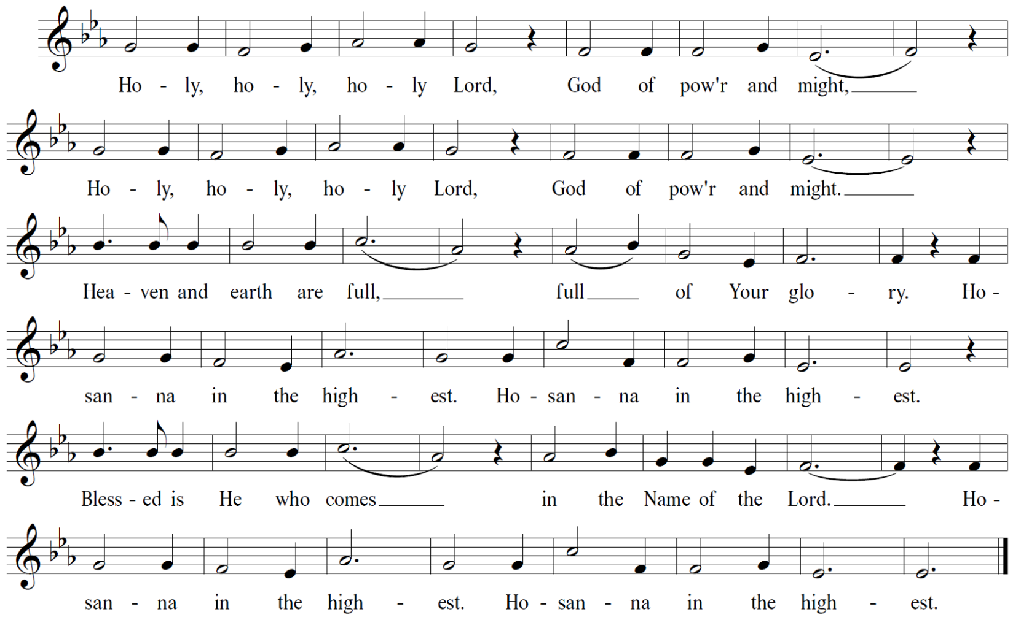

Holy, mighty, and merciful Lord, heaven and earth are full of Your glory. In great love You sent to us Jesus, Your Son, who reached out to heal the sick and suffering, who preached good news to the poor, and who, on the cross, opened His arms to redeem us all.

In the night in which He was betrayed, our Lord Jesus took bread, and gave thanks; broke it, and gave it to His disciples, saying: “Take and eat; this is My body, given for you. Do this for the remembrance of Me.”

Again, after supper, He took the cup, gave thanks, and gave it for all to drink, saying: “This cup is the new covenant in My blood, shed for you and for all people for the forgiveness of sin. Do this for the remembrance of Me.”
Remembering, therefore, His death, His resurrection, and His ascension, we await His coming in glory.

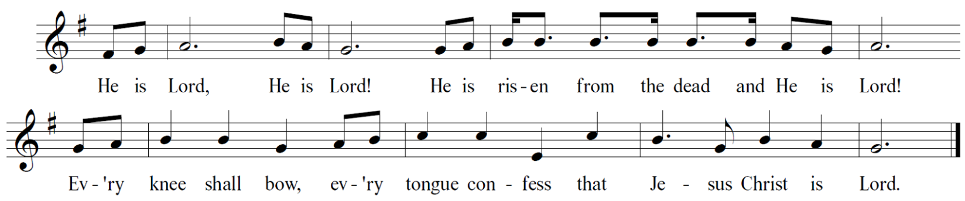

Pour out upon us the Spirit of Your love, O Lord, and unite the wills of all who share this heavenly food, the body and blood of Jesus Christ, our Lord; to whom, with You and the Holy Spirit, be all honor and glory, now and forever.
Amen.

* THE LORD’S PRAYER
Gathered into one by the Holy Spirit, let us pray as Jesus taught us.

Our Father, who art in heaven, hallowed be Thy Name. Thy kingdom come, Thy will be done, on earth as it is in heaven. Give us this day our daily bread, and forgive us our trespasses, as we forgive those who trespass against us. And lead us not into temptation, but deliver us from evil. For Thine is the kingdom, the power, and the glory, forever and ever. Amen.

(Please be seated.)

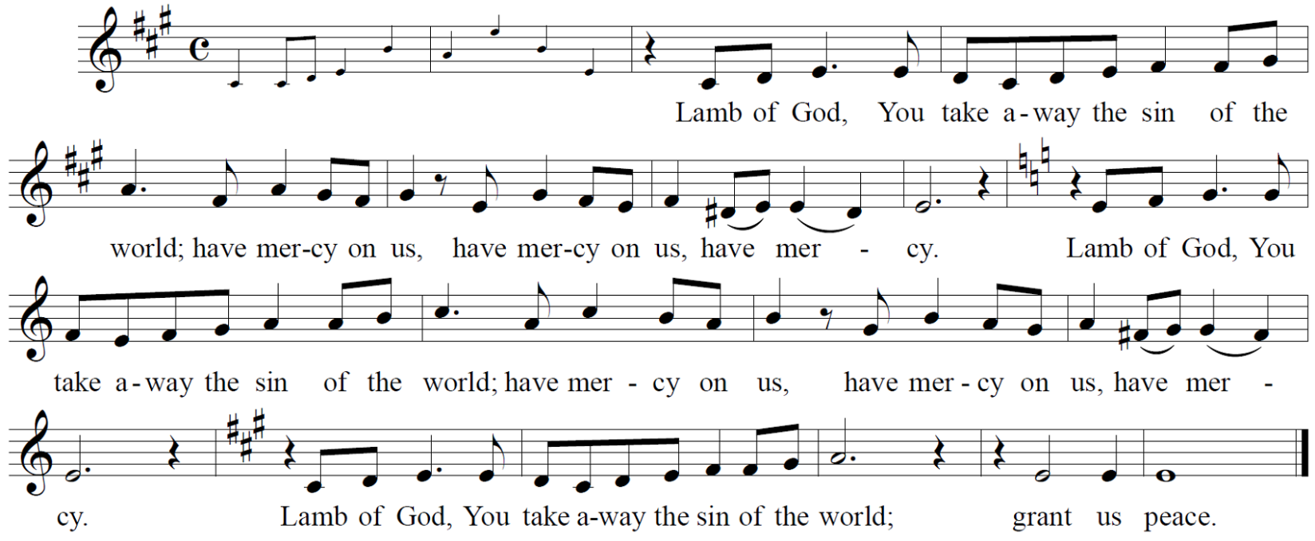

the distribution

(At the usher’s invitation you are invited to come forward to pick up your communion set. As the Pastor hands you the communion set, he will say “The body of Christ; given for you – The blood of Christ; shed for you.” Once everyone has returned to their seats and is seated, we will commune together by eating the wafer first and then drinking the grape juice when the Pastor says – “Let us partake of the gifts we have received.”)
Let us partake of the gifts we have received.

The body and blood of our Lord Jesus Christ strengthen you and keep you in His grace.
Amen.
* PRAYER AFTER COMMUNION

Let us pray.
Life-giving God, in the mystery of Christ’s resurrection You send light to conquer darkness, water to give new life, and the bread of life to nourish Your people. Send us forth as witnesses to Your Son’s resurrection, that we may show Your glory to all the world, through Jesus Christ, our risen Lord. Amen.

* Blessing

The Lord bless you and keep you.
The Lord make his face shine on you and be gracious to you.
The Lord look upon you with favor and ☩ give you peace.
In the name of the Father, Son and Holy Spirit.
Amen

* HYMN
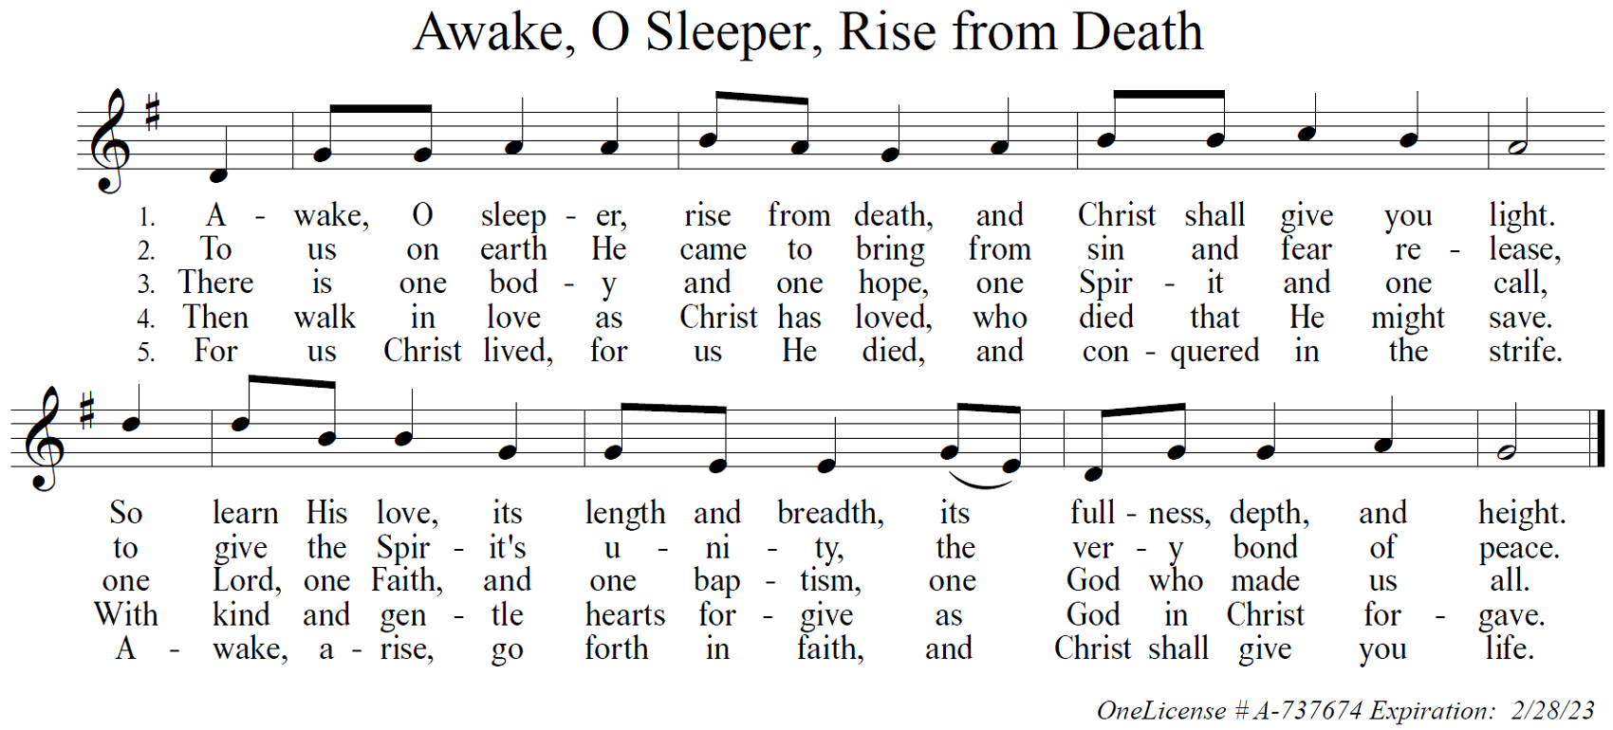
* DISMISSAL

Go in peace. Share the good news that He is risen!
Alleluia! He is risen indeed!

POSTLUDE

(Adapted) From sundaysandseasons.com. Copyright © 2022 Augsburg Fortress. All rights reserved.

ANNOUNCEMENTS

Information to contact Pastor Gregg:

Cell phone: 1-443-397-5970 (It was printed incorrectly in the email that went to the congregation.

Office Hours: Monday and Tuesday 10:00-2:00 pm, Wednesday Noon – 4:00 pm
ANY TIME BY APPOINTMENT

WORSHIP COMMITTEE MEETING TODAY AFTER SUNDAY SCHOOL. All members are asked to attend. See Dave Wood with questions.

There is a VBS Planning Meeting TODAY after worship. We need helpers for July 11 -14. Everyone is welcome! See Stacey Weihaus with questions.

We need strong legs and sharp eyes to help with the Brookline Yard Sale on Saturday, June 4. Contact Cheryl Vergot (412-719-6205) if you are willing to help in ANY way!

Samantha Langhoff | 5/14
Gloria Aul | 5/15
Howard Ingold | 5/16
Tiffany Zinn | 5/20
Melissa Haas | 5/21
Michele Tonti | 5/21
Paul Bernhard | 5/22
Jenna Rose Zottoli | 5/31
Happy Birthday to . . .

This Photo by Unknown Author is licensed under CC BY-NC

Council meeting on Tuesday at 7:00 pm. The meeting from last Tuesday was postponed until THIS Tuesday. We will be zooming. Sue will send out the information to Zoom. Please send your reports to Sue for inclusion in the minutes.

Pentecost is coming up FAST! June 5 is the date to celebrate the Church’s birthday. Mark your calendar to BE HERE!

You are invited to attend Pastor Gregg’s Installation on June 5 at 3:00 pm.
Reception to immediately follow the service.

Don’t forget your gift of peanut butter and jelly for this month’s Meals on Wheels Food Gathering. Please place your donation in the blue basket in the Breezeway. If you have a question, please see Sue Earley (724-825-8634)

MEALS ON WHEELS Food Gathering
May peanut butter and jelly
June canned vegetables
July canned fruit, especially crushed pineapple
August Ziploc sandwich bags, paper towels
September sugar free Jello & pudding mix
October serving size cups of unsweetened applesauce, fruit in juice
November peanut butter and jelly
December canned vegetables
January canned fuit, especially crushed pineapple
February Ziploc sandwich bags, paper towels
March sugar free Jello & pudding mix
April Serving size cups of unsweetened applesauce, fruit in juice

GOSPEL MESSAGE
May 15, 2022
5th Sunday of EASTER

We Are Found

As Jesus in today’s gospel prepares the disciples for his imminent departure, he tells them that they will look for him but won’t be able to join him where he is going. It will not be long before the women are at the tomb in the early morning, only to find it empty.
We also look for Jesus, but perhaps we don’t know that we are engaged in the search. We are constantly seeking purpose and answers, turning to self-help books, inspirational videos, exercise programs, and new ways of organizing our stuff. Billboards and magazine covers highlight our flaws while offering the next best solution to make us happy and well.
These opportunities can be compelling, and some of them will prove successful in managing some aspects of life. But these solutions don’t turn up what we’re really looking for: to be truly loved and known, secure and whole. We find this security only in the love of God. Yet, in this Easter season we are reminded that we do not need to seek Jesus; rather, Jesus seeks out and finds us. We cannot go where Jesus goes, leading the way through death to new life, but Jesus ultimately finds us wherever we are, even when we are most lost. The women found an empty tomb, but Jesus is not gone. The resurrected Jesus finds them!
In finding us, Jesus also directs our searching by giving us a commandment: “Love one another” (John 13:34). In seeking to love one another, we are reminded again and again that the great love of God has already found us.

