August 21, 2022
Eleventh Sunday in Pentecost

St. Mark’s Lutheran Church
933 Brookline Blvd.
Pittsburgh, PA 15226
412-531-9575
Rev. Gregg Knepp
Phone: 443-397-5970

Internet : stmarkbrookline.wixsite.com/smlc
Email : stmarklutheranchurch@verizon.net
Facebook : facebook.com/SMLCbrookline

Please join us on Zoom at 9:30 am Sunday

Join by computer using Zoom: Meeting ID = 856 2680 1615 Password = church
OR
Join by phone: Dial-in # = (301) 715-8592
Meeting ID = 856 2680 1615 Password = 280633

Our Purpose
We are called and empowered by God to lead our family, friends, and community
into a deeper relationship with Jesus Christ.
Our Mission
We will listen to, equip, and accompany each person on their journey to know
God’s love and the plan of salvation.
+ + + + + +

Introduction to the day

Remember the sabbath day. Call the sabbath a delight. This is the Lord’s day, and the Lord will do for us what the Lord does: feed us, forgive us, help and heal us. Rejoice at all the wonderful things God is doing.
+ + + + + +
St. Mark’s Evangelical Lutheran Church
Eleventh Sunday in Pentecost

Order of Worship
* Please stand as you are able.

PRELUDE

ANNOUNCEMENTS

SHARING God Sightings

* (Please stand.)

* Gathering

The Holy Spirit calls us together as the people of God.

Blessed be the holy Trinity, ☩ one God, who forgives all our sin, whose mercy endures forever.
Amen.

* Confession and forgiveness

Let us confess our sin in the presence of God and of one another.
Silence is kept for reflection.
Merciful God,
we confess that we have not followed your path
but have chosen our own way.
Instead of putting others before ourselves,
we long to take the best seats at the table.
When met by those in need,
we have too often passed by on the other side.
Set us again on the path of life.
Save us from ourselves
and free us to love our neighbors.
Amen.

Hear the good news!
God does not deal with us according to our sins
but delights in granting pardon and mercy.
In the name of ☩ Jesus Christ, your sins are forgiven.
You are free to love as God loves.
Amen.

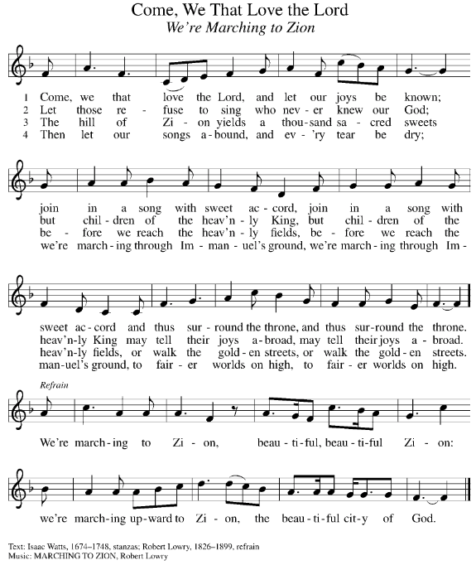
* HYMN

Public Domain

* GREETING

The grace of our Lord Jesus Christ, the love of God, and the communion of the Holy Spirit be with you all.
And also with you.
* SONG OF PRAISE (Verses 1 & 3)

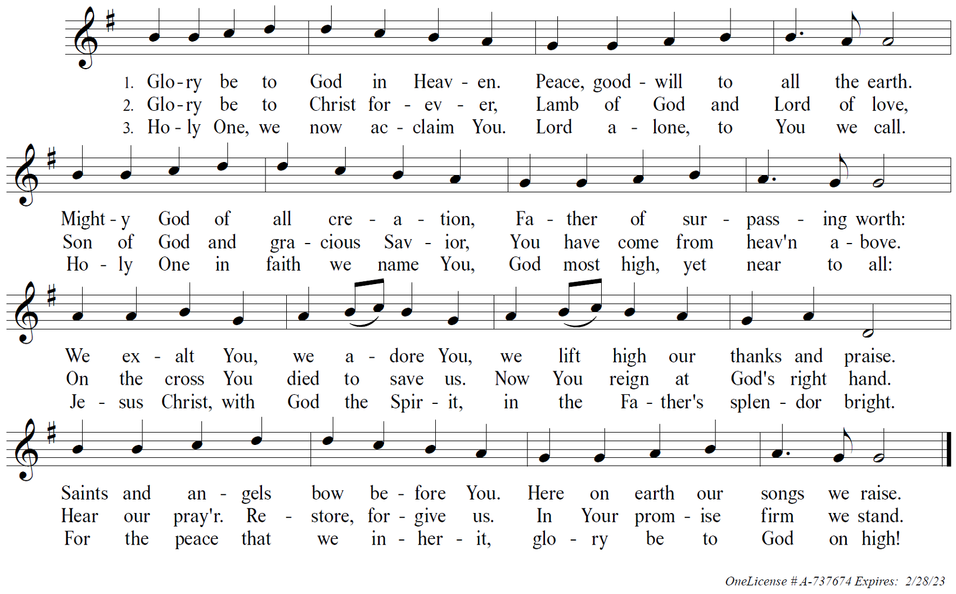
* Prayer of the Day

Let us pray.

O God, mighty and immortal, you know that as fragile creatures surrounded by great dangers, we cannot by ourselves stand upright. Give us strength of mind and body, so that even when we suffer because of human sin, we may rise victorious through your Son, Jesus Christ, our Savior and Lord.
Amen.

(Please be seated.)

THE WORD

FIRST READING: Isaiah 58:6 - 14 Reader: Cheryl Vergot
⁶Is not this the fast that I choose:
to loose the bonds of injustice,
to undo the thongs of the yoke,
to let the oppressed go free,
and to break every yoke?
⁷Is it not to share your bread with the hungry,
and bring the homeless poor into your house;
when you see the naked, to cover them,
and not to hide yourself from your own kin?
⁸Then your light shall break forth like the dawn,
and your healing shall spring up quickly;
your vindicator shall go before you,
the glory of the LORD shall be your rear guard.
⁹Then you shall call, and the LORD will answer;
you shall cry for help, and he will say, Here I am.
If you remove the yoke from among you,
the pointing of the finger, the speaking of evil,
¹⁰if you offer your food to the hungry
and satisfy the needs of the afflicted,
then your light shall rise in the darkness
and your gloom be like the noonday.
¹¹The LORD will guide you continually,
and satisfy your needs in parched places,
and make your bones strong;
and you shall be like a watered garden,
like a spring of water,
whose waters never fail.
¹²Your ancient ruins shall be rebuilt;
you shall raise up the foundations of many generations;
you shall be called the repairer of the breach,
the restorer of streets to live in.
¹³If you refrain from trampling the sabbath,
from pursuing your own interests on my holy day;
if you call the sabbath a delight
and the holy day of the LORD honorable;
if you honor it, not going your own ways,
serving your own interests, or pursuing your own affairs;
¹⁴then you shall take delight in the LORD,
and I will make you ride upon the heights of the earth;
I will feed you with the heritage of your ancestor Jacob,
for the mouth of the LORD has spoken.

Word of God, word of life.
Thanks be to God.

* ACCLAMATION
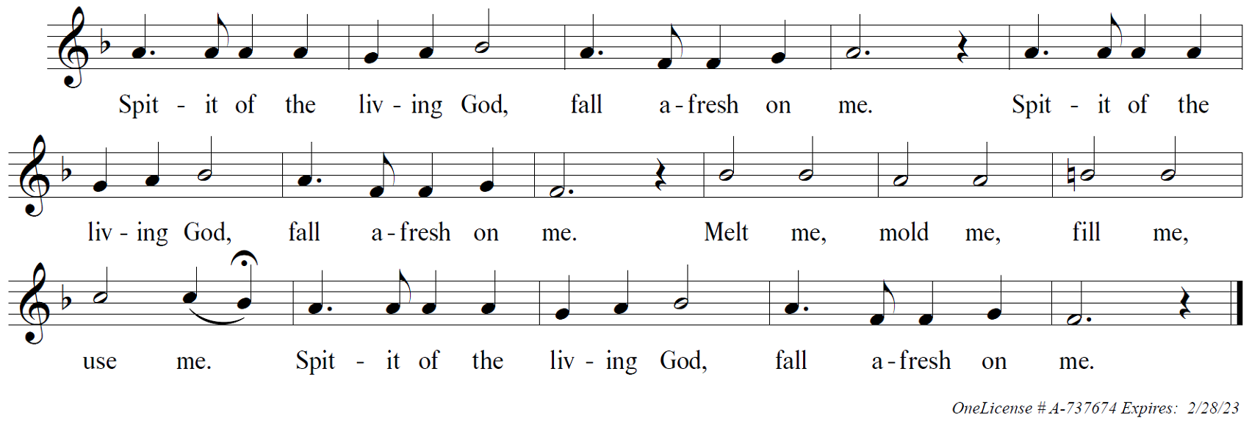

Pastor Gregg

*SECOND READING: Luke 13:10 - 17 Pastor Gregg
¹⁰Now he was teaching in one of the synagogues on the sabbath. ¹¹And just then there appeared a woman with a spirit that had crippled her for eighteen years. She was bent over and was quite unable to stand up straight. ¹²When Jesus saw her, he called her over and said, "Woman, you are set free from your ailment." ¹³When he laid his hands on her, immediately she stood up straight and began praising God. ¹⁴But the leader of the synagogue, indignant because Jesus had cured on the sabbath, kept saying to the crowd, "There are six days on which work ought to be done; come on those days and be cured, and not on the sabbath day." ¹⁵But the Lord answered him and said, "You hypocrites! Does not each of you on the sabbath untie his ox or his donkey from the manger, and lead it away to give it water? ¹⁶And ought not this woman, a daughter of Abraham whom Satan bound for eighteen long years, be set free from this bondage on the sabbath day?" ¹⁷When he said this, all his opponents were put to shame; and the entire crowd was rejoicing at all the wonderful things that he was doing.

Word of God, word of life.
Thanks be to God.

(Please be seated.)

YOUTH MESSAGE

SERMON Pastor Gregg

SERMON NOTES

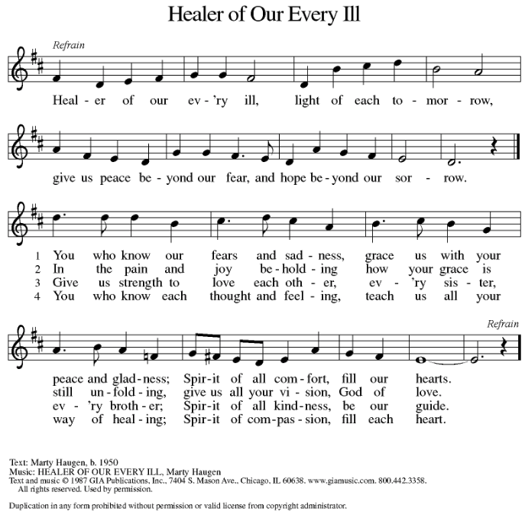
* HYMN

OneLicense # A-737674 Expires: 2/28/23

* PRAYERS OF INTERCESSION
Trusting in God’s extraordinary love, let us come near to the Holy One in prayer.
A brief silence.
You crown your church with steadfast love and mercy. Guide us continually in our baptismal covenant to strive for justice and peace in all the earth. Use our diverse gifts in service to the whole people of God. Merciful God,
receive our prayer.
You satisfy the needs of all creatures. Protect the habitats of fish and birds (local bodies of water or wildlife refuges may be named). Repair ecosystems damaged by misuse, neglect, or natural disaster, that all creation may thrive. Merciful God,
receive our prayer.
You make your ways known to all people. Inspire the rulers and leaders of nations with your compassion and mercy. Raise up activists and community organizers to restore places affected by violence, poverty, and inequality. Merciful God,
receive our prayer.
You provide justice for all who are oppressed and relief to all who are afflicted. Heal those who are bent over by addiction, depression, and anxiety. Set free all who cry out under the weight of mental, emotional, or physical distress (especially). Merciful God,
receive our prayer.
You call us to delight in the sabbath. Renew our bodies, minds, and spirits in this worshiping assembly. Give rest to all who lead our congregation in worship, study, and service (congregational leaders may be named). Merciful God,
receive our prayer.
Here other intercessions may be offered.
Generations bless your holy name. We give you thanks for the communion of saints who have gathered in prayer and praise in this place. Support us in your love until we rest forever in you. Merciful God,
receive our prayer.
Receive the prayers of your children, merciful God, and hold us forever in your steadfast love; through Jesus Christ, our holy Wisdom.
Amen.

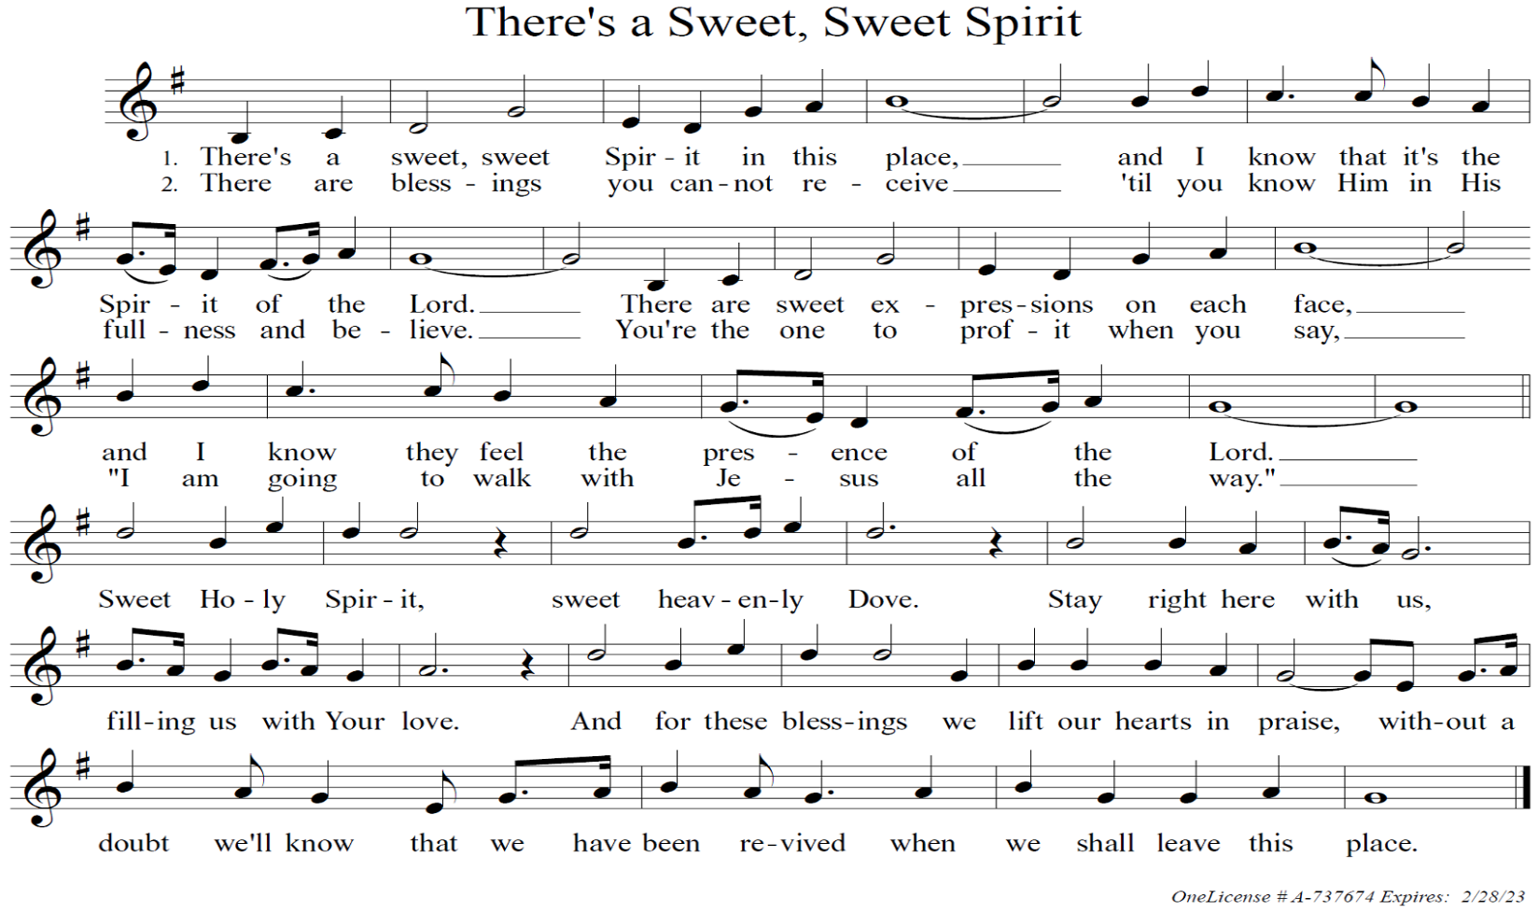
* OFFERING SONG (First verse only)

The peace of the Lord be with you always.
And also with you.

* OFFERING PRAYER
Let us pray.
God of abundance: you have set before us a plentiful harvest.
As we feast on your goodness, strengthen us to labor in your field,
and equip us to bear fruit for the good of all,
in the name of Jesus.
Amen.

* GREAT THANKSGIVING

The Lord be with you.
And also with you.

Lift up your hearts.
We lift them to the Lord.

Let us give thanks to the Lord our God.
It is right to give our thanks and praise.

* WORDS OF INSTITUTION

In the night in which He was betrayed, our Lord Jesus took bread, and gave thanks; broke it, and gave it to His disciples, saying: “Take and eat; this is My body, given for you. Do this for the remembrance of Me.”

Again, after supper, He took the cup, gave thanks, and gave it for all to drink, saying: “This cup is the new covenant in My blood, shed for you and for all people for the forgiveness of sin. Do this for the remembrance of Me.”

* THE LORD’S PRAYER

Our Father, who art in heaven, hallowed be Thy name.
Thy kingdom come, Thy will be done,
on earth as it is in heaven.
Give us this day our daily bread,
and forgive us our trespasses,
as we forgive those who trespass against us.
And lead us not into temptation,
but deliver us from evil.
For thine is the kingdom, the power and the glory,
forever and ever. Amen.

(Please be seated.)

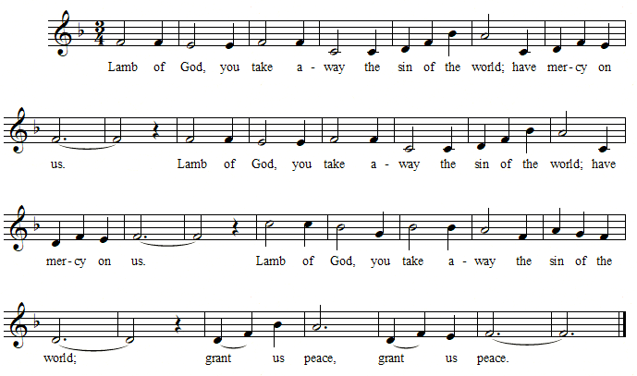
LAMB OF GOD (Setting 5 WOV)

the distribution

(At the usher’s invitation you are invited to come forward to pick up your communion set. As the Pastor hands you the communion set, he will say “The body of Christ; given for you – The blood of Christ; shed for you.” Once everyone has returned to their seats and is seated, we will commune together by eating the wafer first and then drinking the grape juice when the Pastor says – “Let us partake of the gifts we have received.”)

Let us partake of the gifts we have received.

The body and blood of our Lord Jesus Christ strengthen you and keep you in His grace.
Amen.

POST COMMUNION BLESSING

The God of peace, Father, ☩ Son, and Holy Spirit, bless you,
comfort you and show you the path of life this day and always.
Amen.

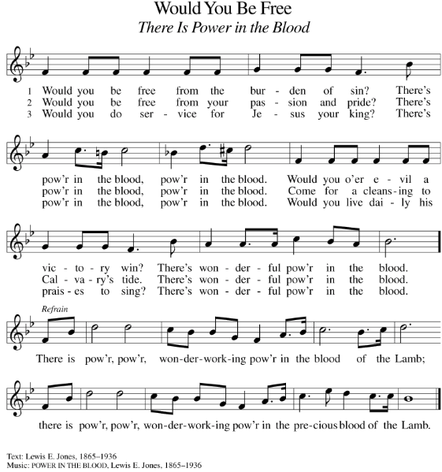
POST COMMUNION

Public Domain

- PRAYER AFTER COMMUNION

Let us pray.

Life-giving God, through this meal you have bandaged our wounds
and fed us with your mercy. Now send us forth to live for others,
both friend and stranger, that all may come to know your love.
This we pray in the name of Jesus.
Amen.

* Blessing

The Lord bless you and keep you.
The Lord make His face shine on you and be gracious to you.
The Lord look upon you with favor and ☩ give you peace,
In the name of the Father, Son and Holy Spirit.
Amen.

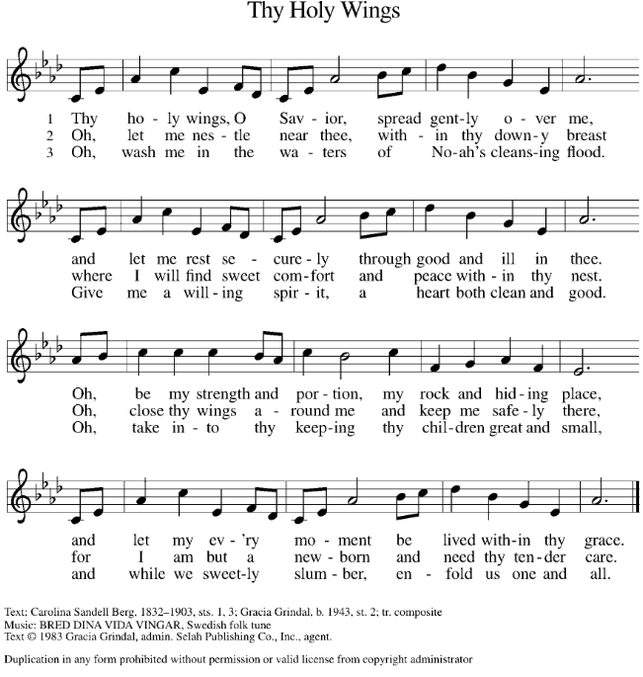
* HYMN

OneLicense # A-737674 Expires: 2/28/23

* DISMISSAL

Go in peace. Love your neighbor.
Thanks be to God.

POSTLUDE

(Adapted) From sundaysandseasons.com. Copyright © 2022 Augsburg Fortress. All rights reserved.

+ + + + + + + + + + + + + + + + + + + + + + + + + + + +

ANNOUNCEMENTS

“Why in the World?”

For the first Sunday of the month, September 4th, Pastor Gregg will discuss questions regarding “End of Life Decisions” and leaving a legacy for our loved ones. Topics will include: What do Lutherans believe about Eternal Life, Living Wills and Advance Funeral Preparation. Please join us.

-- -- -- -- -- --

Dora Cook | Aug 10
Nancy Gibbs | Aug 12
Cameron Noar | Aug 13
Norman Drexler | Aug 15
Donald Coester | Aug 23
Susan Earley | Aug 24
Diane Kwasniewski | Aug 25
Suzanne Miller | Aug 27
Joan Mussomeli | Aug 30
Happy Birthday to . . .

This Photo by Unknown Author is licensed under CC BY-NC

-- -- -- -- -- --

The August Meals on Wheels Food Gathering has a need for Ziploc sandwich or gallon size bags, 33 gallon trash bags or paper towels. Please place your donation in the blue basket in the Breezeway. If you have any questions, please see Sue Earley (724-825-8634). As always, your generosity is greatly appreciated. Thank you.

-- -- -- -- -- --

Community 341 is requesting….
Socks toothpaste toothbrushes soap body wash deodorant
feminine hygiene products (regular pads) wash cloth hand towel wipes
There will be a collection box in the breezeway. Any questions see Susan Earley.

-- -- -- -- -- --

Save The Date Lady Lions!
Lady Lions will be meeting the first Saturday of November, the 5th, at 9:30 AM. Project Linus Instructions and Projects by Peggy Kelley will be the main topic. Any questions see Susan Earley.
-- -- -- -- -- --

Teller Schedule for Remainder of 2022

Month | Teller | eMail | Phone
August | Jeff Arnold | jeffsarnold29@gmail.com | 412-668-0531
September | Ray Prosser | hray.jcp@verizon.net | 412-977-9018
October | Bill Willis | williamkwillis@gmail.com | 412-655-2864
November | Gary Byers | xgbyers@verizon.net | 412-563-6591
December | Howie Ingold | pappap7boys@yahoo.com | 412-760-0078

-- -- -- -- -- --

Lectors for Next 4 Weeks

Date | Lector
August 28 | Karen Arnold
September 4 | Sue Earley
September 11 | Dave Wood
September 18 | Sirena Weihaus

-- -- -- -- -- --

Fall Plans for Spiritual Growth

Bible Study: Every Tuesday at NOON. Beginning Sept. 13th.
(The Gospel of John: Church and Culture in Conflict)

Spiritual Reading Group: 2nd Mondays
(Convictions: How I Learned What Matters Most) by Marcus Borg

Pub Theology: 1st and 3rd Tuesdays, 6:30-8:00 pm.
Beginning Sept. 20th at The Getaway Bar & Grill, 3049 Sussex Ave.

Faith Movie Night: 1st Wednesdays, 6 pm. Beginning Sept. 7

First Communion: Four Sessions after church: 2 in Sept and 2 in October, celebrate 1st Communion on Reformation Sunday, October 30th.

Variation of Trunk Or Treat on October 31st.

Christmas Play OR…
Live Nativity, Dec. 24th at 6:00 pm; Worship at 7:00 pm

+ + + + + + + + + + + + + + + + + + + + + + + + + + + +

GOSPEL MESSAGE
August 21, 2022

A Good Time for Liberation
Luke tells us that Jesus had such compassion for an ailing woman that he healed her without waiting. It’s hard to imagine what it was like for her to be bent over for eighteen years. Anyone who has known back pain knows how debilitating it can be. The image of her stooped over is quickly transformed when she is healed, is liberated from her ailment, and stands up straight. She is set free from pain and social isolation. She spontaneously praises God. How could she not?
Some people present with Jesus and the woman did not celebrate or praise God. They complained that Jesus’ timing was bad. It was the Sabbath day. Sabbath is a holy gift from God given for God’s people to have rest, to be free from the burdens of labor, and to enjoy life in community with one another and God. Some thought restrictions against doing work meant it was a bad time for healing. They failed to see that as good as Sabbath-keeping is, there is never a bad time for healing. It is always the right time to liberate people from whatever disease and oppression keeps them bent over and suffering.
Luke’s message is that Jesus comes to bring God’s liberation for the poor, oppressed, sick, and sinful. Through mercy granted unconditionally, a new world is formed in Christ where it is always a good time for healing and liberation. Just as Jesus lifted up the woman bent over in pain, God lifts up the lowly and humble to give them life and liberty.
God surprises us with grace that comes even when we think it can’t be the right time. Whether it is God claiming us in Christ through baptism, or granting healing from disease, or lifting up people bent over from marginalization, it is always the right time. How could we not offer our spontaneous praise as we are lifted up by such good news?

+ + + + + + + + + + + + + + + + + + + + + + + + + + + +

